#1. Monthly Revenue & Order Volume (Amazon Sales)

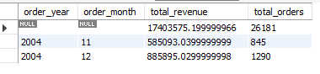

#2. Yearly Sales Growth

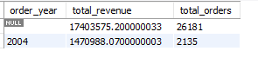

#3. Top 5 Months by Revenue

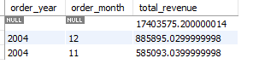

#4. International Sales by Month

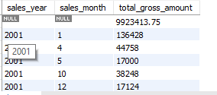

#5. Revenue Contribution by Category (Amazon)

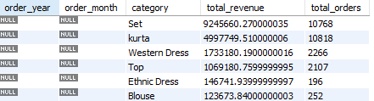

#6. Year-Month Trend (Combined Sales)

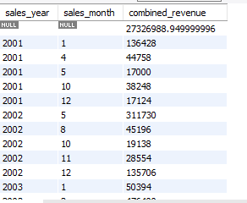

#7. Quarter-wise Sales



#8. Revenue vs Orders Trend

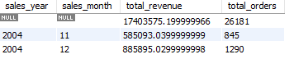

#9. Filter for Specific Period



#10. Top Customers in a Period

